Assignment 2

btec it | Gargi Gupta

Effective it communication

Simon Light

2015

Contents

P4 2

Day 1 2

Day 2 2

Day 3 2

Presentation 2

P5 3

Word processing 3

Presentation software 4

Email 4

Specialist 5

P6 5

M2 7

D1 9

James 9

Sean and Phil 9

Skills that worked within the team 10

Skills that did not work within the team 10

How we overcame obstacles 10

# P4

## Day 1

On the first day of the project we were spoken to prudential about what our challenge will be. We were told that is was to be on the uses of big data. They then proceeded to explain big data fully and showed some modern day examples. They also told us that there was going to be 4 groups: Design and Build, Marketing, Software Development and Research and analysis. We then went off with our companies to select which one of these groups we would like to be in. Once all of the teams were selected and balanced, each team was split up into 4 competencies named 1, 2, 3 and 4. This is so when we were working on the second day we could have teams of people from different specialisms (software and design and marketing and analysis).

## Day 2

On the second day we were grouped as shown above (teams of different specialisms) and set the task of creating the idea for a product. We proceeded to communicate within our groups to find out if any team members had any ideas we could brainstorm off of. Once we had some starting ideas we discussed them within our team until they had expanded into a fully-fledged idea. Once we had done this we went to a room with our whole company and pitched them to the rest of the company. This is where I gave the presentation.

## Day 3

On the third day we were giving the ideas that had been selected and asked to make a plan of the product. We had to make a list of things we believed that we could do, and a list of things that we wanted other groups to do. This meant that we could not be blamed for any mistakes in the project and for not doing things we didn’t say that we were going to do. We then presented our information to the rest of the competencies and noted what they wanted us to do. We also discussed these points and made sure that everyone understood.

## Presentation

I gave a presentation to the whole company so that they could decide which product each team should make. I was to present a ‘smart’ fridge idea. Before the presentation I wrote up about the product and all of the positive points of it that were going to be relatable to the people listening. I then noted down all of the bad points of the product and interpreted some questions that I may be asked and thought of some responses for those. This meant I was ready for everything that may happen. When I was giving the presentation I engaged all of the audience by making eye contact and asking open and specific questions to the audience. This meant that they all knew what my product was and the benefits of it. This meant that they would be more likely to choose our product. I ended the presentation by summarising the product and the key points about. This left them with a lasting impression on the audience of the good points of my product.

# P5

## Word processing

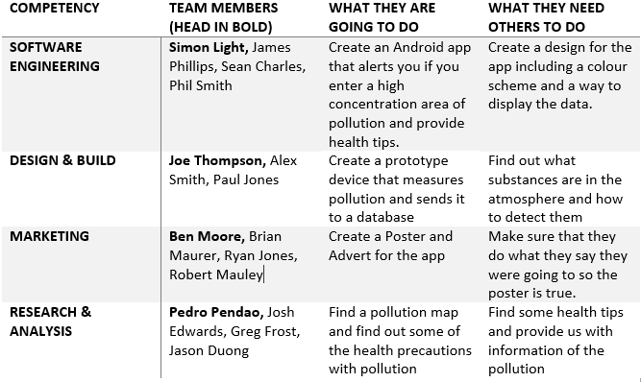

The use of word is useful as it means I can quickly and easily make a professional looking note. In this case I have made a note of the competency, team members and leaders, what they are going to do and what they need others to do. I then added one of the table pre-sets which means I could share this with it looking professionally made.

## Presentation software



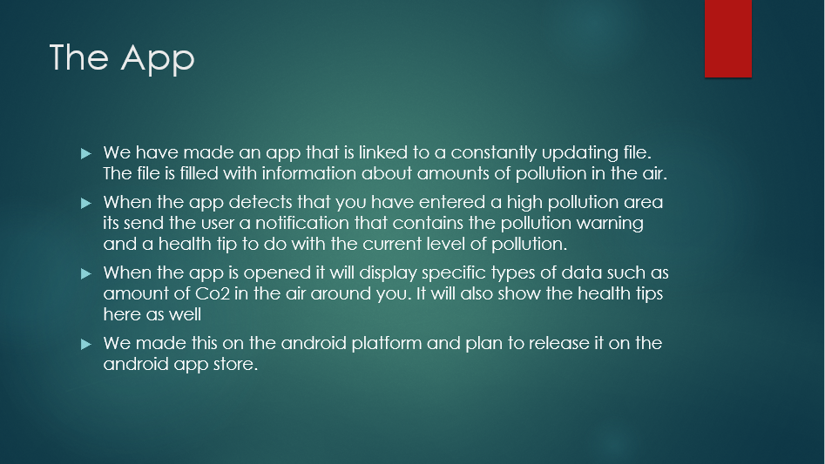

This is a presentation that we gave to the rest of the competencies at the end of day 3. We showed our idea for the app and then explained the things that we were going to do and what we needed others to do. We used slide animations to keep everyone’s attention so that we could make sure that they knew what they had to do. After the presentation we exported and emailed everyone a copy of the presentation so that they had a hard copy of the information for reference.

## Email

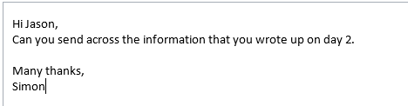

With email I can send messages to individual people. I can also add them to events and attach documents to them. This is useful for communication as they can be sent at any time (you don’t have to wait until you see the person), you can give people virtual copies of documents which means they can edit it as necessary.

## Specialist - OneNote

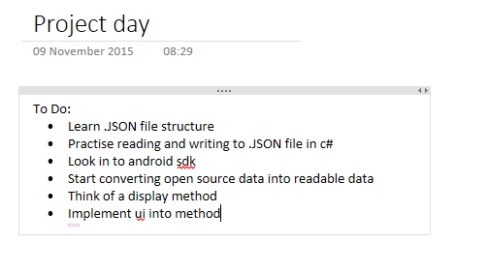

OneNote is a very useful tool for organisation. It is useful as I can link people to the OneNote in a user or viewer type. This means that they can edit or just view respectively. I can type all notes from meetings onto here so that we all have a copy and any questions can be put directly on there for someone to answer. You can also add tags e.g. to do tag which is a tick box that can be searched for. This allows someone to quickly and easily search through a document for tasks.

# P6

|  |  |  |
| --- | --- | --- |
| Slide 1 |  |  |
| Slide 2 |  |  |
| Slide 3 |  |  |
| Slide 4 |  |  |
| Slide 5 |  |  |

# M2

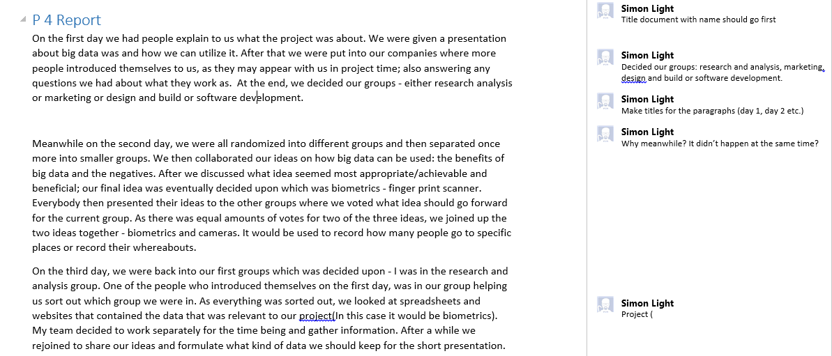

This is an edit that I made to one of my team members documents. This was so that when presenting the document he knew that it made sense and it wasn’t missing any important information.

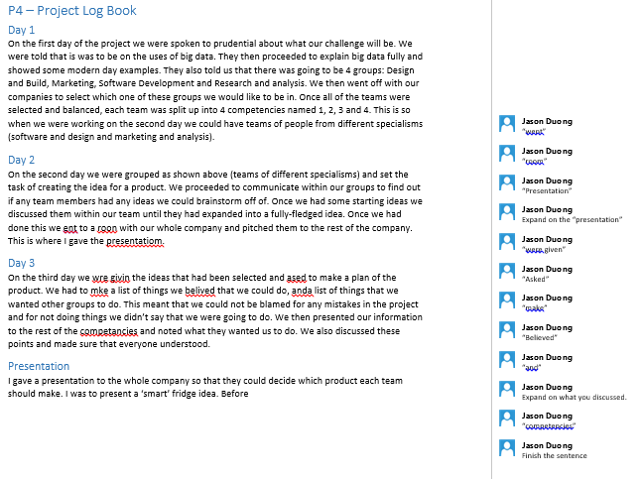

This is a document that someone else in my team edited for me. This was so that when presenting the document I knew that it made sense and it wasn’t missing any important information. This is similar to the autocorrect feature in Word but it can be used for grammar, flow and content as well.

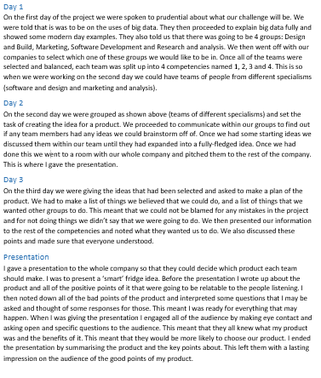

This is the same document after I accepted/declined the comments given. This is useful as I can then check corrections and make sure they are legitimate and correct. The same can be done the other way around (on the document I corrected)

# D1

The people in my team are James, Sean, Phil and I.

## James

James is the team leader and knows a lot about app development (the main area of focus for our software). He held the floor well while letting others put their point of view in. He did well to adapt with quieter people in our group by speaking to them more quietly which made them feel like they were only speaking to him not the whole group. He represented the groups ideas on a whiteboard using a mind-map and came back to it at the end of our discussions to take any notes we needed. He took these notes and then placed them onto a OneNote which we could all edit and add to if necessary. This was laid out well in a table and was very easy to read and understand. He was very upbeat and never criticised any ideas but more incorporated them all into the goal. He took ideas off of his own back but mainly asked others for their ideas. He was very attentive to all of us and never let anyone get distracted.

## Sean and Phil

Sean and Phil were very similar. They were not very open to sharing their ideas at the start. Once we started to talk to them we realised that they had a wealth of information about .JSON files (the file type we want to store data on). This had to be eneouraged out with direct questions by James and I, other than this they didn’t offer much assistance. When explaining their knowledge they never made eye contact and rushed through what they were saying. This made it very hard to understand them especially as we have never learnt this before. After the project day they didn’t add anything to the OneNote unless directly asked to and when they did, they included spelling and grammar mistakes. They often went into far too much or too little detail about the information which again made it confusing. They didn’t have a positive body attitude at all and talked to each other rather than the group

## Skills that worked within the team

Use of intonation, Positive Language, Active engagement, summarising, paraphrasing, types of questions, speed of response, structure, identifying relevance, proofreading and note taking

## Skills that did not work within the team

Signing, Lip reading, Techniques and cues e.g. body language, Negative language, Barriers e.g. background noise, Distractions, Lack of concentration, Guideline, ‘Smiley’s’ or emoticons, Key message e.g. letter, fax, email, Grammar and Spelling

## How we overcame obstacles

The way we overcame almost all obstacles was by setting small tasks to each member of the group. This meant everyone knew what they were meant to be doing which meant everyone could be working at the same time. We nicely combined this with asking questions (both of each other and our mentors). This meant that if we had any trouble with the work we were doing we asked the rest of the group and if they didn’t know then we asked a mentor. This meant that every time we had a query we didn’t have to wait for a mentor to finish talking to another group and come and see us, instead solutions were found in about 10 seconds either by using our own knowledge or by using information given to us.